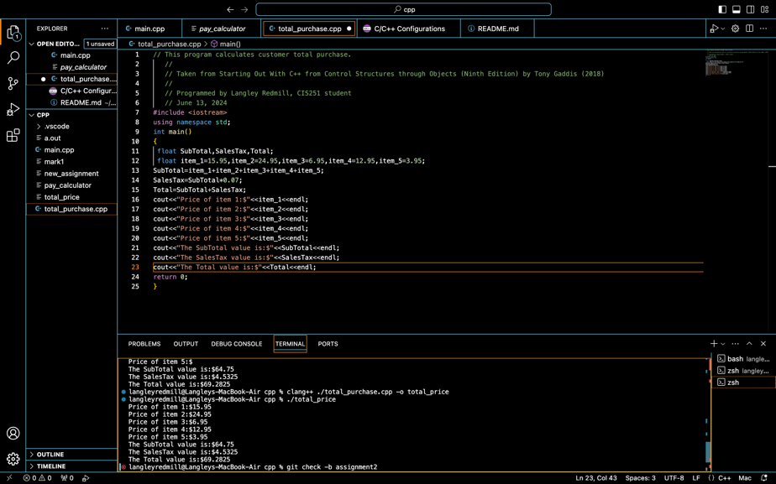
// This program calculates customer total purchase.
//
// Taken from Starting Out With C++ from Control Structures through Objects (Ninth
Edition) by Tony Gaddis (2018)
//
// Programmed by Langley Redmill, CIS251 student
// June 13, 2024h
#include <iostream>
using namespace std;
int main()
{
Float SubTotal,SalesTax;Total;
Float item_1=15.95,item_2=24.95,item_3=6.95,item_4=12.95,item_5=3.95;
SubTotal item_1+item_2+item_3+item_4+item_5;
SalesTax=SubTotal*0.07;
Total=SubTotal+SalesTax;
cout<<"Price of item 1:$"<<item_1<<endl;
cout<<"Price of item 2:$"<<item_2<<endl;
cout<<"Price of item 3:$"<<item_3<<endl;
cout<<"Price of item 4:$"<<item_4<<endl;
cout<<"Price of item 5:$"<<item_5<<endl;
cout<<"The SubTotal value is:$"<<SubTotal<<endl;
cout<<"The SalesTax value is:$"<<SalesTax<<endl;
cout<<"The Total value is:$"<<Total<<endl;
return 0 }